The Taber Public Library Board enacts the following bylaws pursuant to the Libraries Act. S.A. 1998,
Chapter 1-12.1, section 40.

Part 1 – Interpretation

- For the purpose of these bylaws, the expression

“Board” means the Taber Public Library Board

“Hours of Opening” means the hours, as set from time to time by the Board, that the Library is open to the public for the purpose of using or borrowing materials.

“Library” means the Taber Public Library or, if the context so requires, any premises used by the Taber Public Library for library purposes.

“Library Resources” means any material, regardless of format that is held in a library’s collection and includes books, periodicals, audio recordings, video recordings, projected media, paintings, drawings, photographs, micro-materials, toys and games, kits, cd-roms, and electronic databases.

“Loan Period” means the period of time, as set out in Schedule D, which a member may borrow
library materials and includes renewal of an original loan period.

“Library Manager” means the person in charge at any given time in the library.

- The headings used herein are for convenience and do not form part of these bylaws.

- The Interpretive Act, shall apply to the interpretation of these bylaws.

Part 2 – Use of the Library Premises

- Every member of the public shall have free access during the hours of opening to those public areas of the library normally used for library purposes or designated for library purposes.

- Every person using library premises shall conduct himself or herself so as not to disturb other persons in the library or cause damage to library property.

- Snacks and beverages are allowed in the public areas of the library at the discretion of library staff.

- No animals are allowed in the library other than by people with a disability who may bring their qualified service dog or animals being used in library programs.
- Smoking and/or e-cigarettes are not permitted anywhere on library premises, including outside area and grounds.

Part 3 – Use of Library Materials

1. There is no charge for the use of library materials.

2. All circulating materials may be borrowed by any person presenting a valid library membership card subject to any age restrictions on the card. In the case of a junior membership, the borrower is restricted to junior materials of up to twenty (20) items at a time. TAL (The Alberta Library) memberships are restricted to five (5) items at a time and patrons from Safe Haven are restricted to three (3) items at a time.

3. The owner of a library membership card is financially responsible for all materials taken out on that card.

Memberships

4. An application for library membership shall:

- include a current address, place of residence and telephone number and
- be accompanied by the appropriate membership fee, if any, as set out in Schedule C.
- in the case of a junior membership, the following is required:
    - parental/guardian consent with the understanding that they are responsible for all fees/fines incurred on the junior membership
    - proof of address as provided by a parent/guardian

5. The applicant will be asked for proof of his/her address and/or Driver’s License.

6. All library card holders will be informed of the “Chinook Arch Regional Library
System” services as provided by the library.

7. There shall be the following categories of individual memberships:

- Adult Resident (18 and over)
- Young Adult Resident (12-17)
- Juvenile Resident (11 and under)
- Adult MD Resident (18 and over)
- Young Adult MD Resident (12-17)
- Juvenile MD Resident (11 and under)
- Non-Resident (anyone living outside the MD of Taber)
- Taber Talking Book (patrons who are registered with CNIB)
- Taber Staff (library staff)
- TAL (The Alberta Library)
- ME Card

8. A member shall notify the library of any change in address or telephone number.

9. There shall be a fee for the replacement of a lost or damaged library card. See Schedule C.

Part 4 – Other Charges, Fines and Penalties

Other Charges

1. The library may charge a recovery fee for the expenses incurred by it for contract services that are over and above the normal services extended to its patrons.

Overdue Materials

2. a) A member shall return materials by the date of expiration of the loan period, as set out in Schedule D, and upon default pay a fine, as set out in Schedule E.

b) In special circumstances, the fine may be waived by the Library Manager.

Lost and Damaged Materials

3. A user of library materials shall take proper care of the library materials and shall compensate the library for lost or damaged materials according to the tariff set out in Schedule F.

Suspension and Revoking of Library Privileges

4. The library privileges of any person who is in breach of any of the within bylaws may be suspended or revoked at the discretion of the Library Manager.

Prosecution

5. a) Any person who willfully contravenes any of the within bylaws or who willfully retains any library materials from the library is guilty of an offense pursuant to section 45 of the Libraries Act, and may be prosecuted in the Provincial Court of Alberta and be liable to such penalties as are specified in the Summary Convictions Act, in addition to any liability that may attach civilly or under the Criminal Code of Canada.

b) Any fine imposed pursuant to the prosecution of an offense under this section inures to the benefit of the Board in accordance with Section 45 of the Libraries Act.
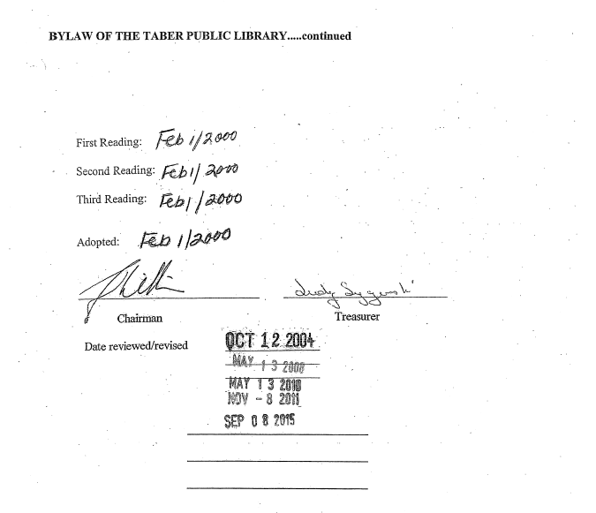

Date of Approval: October 3, 2000

Date Reviewed/Revised: November 9, 2004
September 9, 2008
October 12, 2010
June 11, 2013
October 13, 2015
September 10, 2019
February 11, 2020
October 14, 2021
November 17, 2022
October 12, 2023

